

UPDATED PUBLIC STATEMENT
OF THE OFFICE OF THE OMBUDSMAN IN COMPLIANCE WITH SECTIONS 7, 8 and 9 OF THE FREEDOM OF INFORMATION ACT (FOIA) 1999

In accordance with Sections 7, 8 and 9 of the Freedom of Information Act, Chap. 22:02 (‘FOIA’) the Office of the Ombudsman (hereinafter referred to as the ‘Office’) being a Public Authority is required by law to publish the following statements, which list the documents and information generally available to the public.

The FOIA gives members of the public:
- A legal right for each person to access information held by the Office;
- A legal right for each person to have official information relating to himself /herself amended where it is incomplete, incorrect or misleading;
- A legal right to obtain reasons for adverse decisions made regarding an applicant’s request for information under the FOIA;
- A legal right to complain to the Ombudsman and to apply to the High Court for Judicial Review to challenge adverse decisions made under the FOIA.

The following information is published with the approval of the Ombudsman of Trinidad and Tobago.

SECTION 7 STATEMENTS

SECTION 7 (1) (a) (i)
FUNCTION AND STRUCTURE OF THE OFFICE OF THE OMBUDSMAN

Establishment of the Office of the Ombudsman
The Office was established in 1976 under Section 91 (1) of the Constitution of the Republic of Trinidad and Tobago, Chap. 1:01 (‘the Constitution’) which states “There shall be an Ombudsman for Trinidad and Tobago who shall be an officer of Parliament and who shall not hold any other office of emolument whether in the public service or otherwise now engage in any occupation for reward other than the duties of his office” for the purpose of exercising its functions.

The Office commenced operations in 1977 with the passage of the Ombudsman Act (‘the Ombudsman Act’), Chap. 2:52 and the appointment of its first Ombudsman. At present there are three (3) offices located at:
- Port of Spain (Head Office)- International Waterfront Centre, Level 12, Tower D, 1A Wrightson Road, Port of Spain
- San Fernando: 1st Floor, FinGroup Place, 11-13 Kelshall Street, San Fernando
- Tobago: Caribana Building, Bacolet Street, Scarborough, Tobago
Functions of the Office
The functions of the Office are set out in law as follows hereunder.

- Section 93 (1) of the Constitution which states “…the principal function of the Ombudsman shall be to investigate any decision or recommendation made, including any advice given or recommendation made to a Minister, or any act done or omitted by any department of Government or any other authority.”

- Section 38A (1) of the FOIA which states “A person aggrieved by the refusal of a public authority to grant access to an official document may, within twenty-one (21) days of receiving notice of refusal under Section 23(1) complain in writing to the Ombudsman and the Ombudsman shall, after examining the document if it exists, make such recommendations with respect to the granting of access to the document as he thinks fit within thirty (30) days or as soon as practicable thereof.”

Powers of the Office
The powers of the Office are set out in the sections of the Constitution as follows hereunder.

- 97 (1) The Ombudsman shall have the powers of the High Court to summon witnesses to appear before him and to compel them to give evidence on oath and to produce documents relevant to the proceedings before him and all persons giving evidence at those proceedings shall have the same duties and liabilities and enjoy the same privileges as in the High Court.

- (2) The Ombudsman shall have power to enter and inspect the premises of any department of government or any authority to which section 93 applies, to call for, examine and where necessary retain any document kept on such premises and there to carry out any investigation in pursuance of his functions.

Vision Statement
A Public Administrator that is accountable, fair and transparent for the benefit of all who access public services in Trinidad and Tobago

Mission Statement
The Office of the Ombudsman of the Republic of Trinidad and Tobago will:
- Investigate and seek remedies to complaints of administrative injustice in an impartial and ethical manner (Problem Solving)
- Educate the public on their rights and responsibilities (Public Education)
- Advocate improvements in standards of service delivery in the public sector of Trinidad and Tobago (Advocacy)

Values
Independence│Impartiality│Professionalism│Transparency│Accoutability│Respect

ORGANIZATIONAL CHART OF THE OFFICE OF THE OMBUDSMAN

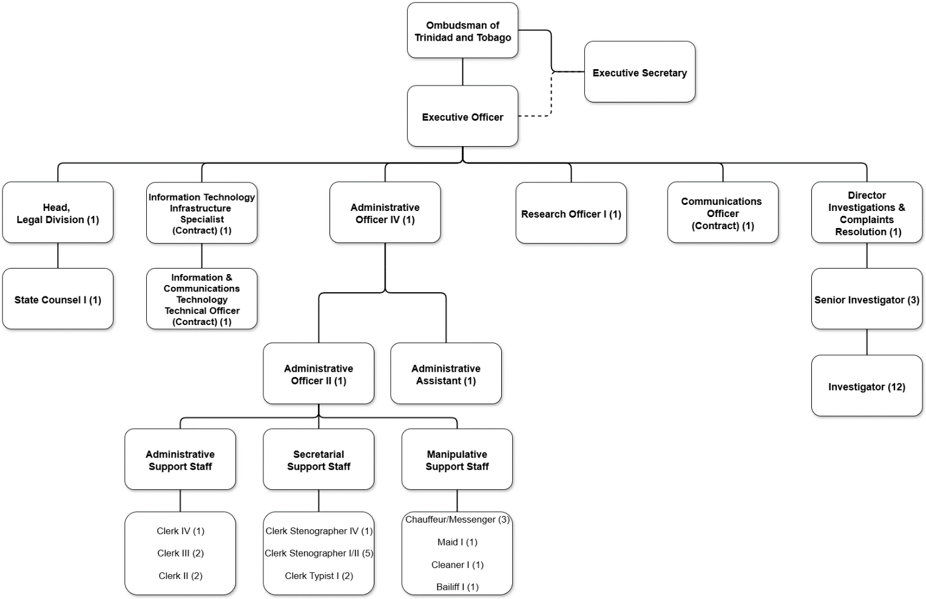

The Office comprises one (1) Ombudsman and the following offices/units:
- Executive Officer
- Legal
- Investigations
- Information Technology
- Communications
- Research
- General Administration

The Office of the Executive Officer
The Executive Officer serves as the Administrative Head of the Office with responsibility for developing Human Resource Management policies and strategies for implementation as well as providing oversight of the Office’s financial requirements.

Legal
The Legal Unit has responsibility for providing the Office with advice on the legal aspects of matters being investigated and on recommendations arising therefrom as well as FOI matters. It also conducts legal research into the laws of Trinidad and Tobago, writes opinions, and gives advice on points of law relevant to complaints received by the Ombudsman.

Investigations
The Investigations Unit investigates complaints from members of the public against government departments and agencies, determines effective remedies/resolutions, and negotiates strategies to implement solutions with the complainant and with senior officials within the department/agency concerned.

Information Technology
This unit provides managerial oversight and technical support in the operations and maintenance of the ICT infrastructure of the Office.

Communications
This unit:
- Establishes and maintains positive public perception of the Office of the Ombudsman through media relations and online customer service delivery (social media community management);
- Engages in public awareness initiatives through traditional and new media to sensitise the public about the services of the Office of the Ombudsman
- Hosts public education campaigns to educate the public about their rights and best practices in conducting their affairs with government ministries, departments and state agencies
Research
The Research Unit organizes and executes research programmes and performs specialized research activities that are pertinent to the administrative procedures, policies, rules, roles and functions of public sector bodies which fall within the remit of the Ombudsman’s jurisdiction.

General Administration
This unit is tasked with managing and directing the work of the General Administrative Support Services Unit of the Office. It consists of three (3) sections that perform the functions of:

- Office Management
- Registry/Records Management
- Administration/Human Resource Management
- Certain accounting functions
- Certain procurement-related activities

SECTION 7(1) (a) (ii)
CATEGORIES OF DOCUMENTS IN THE POSSESSION OF THE OFFICE

- Files, Records, Manuals, Documents:
- Files dealing with administrative documents and for the operations of the Office
- Personnel files, which detail all staff appointments, job applications, job specifications, promotions, transfers, resignations, deaths, retirements, leave, vacation etc.
- Files dealing with the accounting and financial management function of the Office
- Financial Records (cheques, vouchers, receipts, journals, salary records etc.)
- Files dealing with the appointment of the Ombudsman
- Files dealing with training
- Files pertaining to complaints made pursuant to the investigative function of the Office
- Files dealing with circulars, memoranda, notices, etc.
- Correspondence files
- Files dealing with official functions, conferences and events attended by the Office
- Files dealing with matters relating to the procurement of goods and services
- Policy Documents
- Cabinet Documents (Notes and Minutes)
- Inventory Files
- Records and documents relating to the strategic review of the Office
- Contracts, agreements, leases, deeds, concessions and licences
- News releases, speeches and presentations produced by the Office
- Minutes/Agendas of Meetings

- Publications:
- Annual Reports
- Special Reports
- Published Statements
- Journals
- Brochures/Flyers
- Newspapers and clippings therefrom
- Books

- Forms:
- Complaint Forms
- Freedom of Information Act Forms

- Audio Visuals:
- Reels and Tapes

SECTION 7(1) (a) (iii)
MATERIAL PREPARED FOR PUBLICATION OR INSPECTION

The public may inspect and, where applicable, obtain copies of the following materials between the hours of 8:30 a.m. and 3:30 p.m., Monday to Friday (except public holidays) at its Head Office located at:

The Office of the Ombudsman
International Waterfront Centre,
Level 12, Tower D,
1A Wrightson Road,
Port of Spain
Tel: (868) 624-3121

- The Constitution of the Republic of Trinidad and Tobago, Chap. 1:01
- The Ombudsman Act, Chap. 2:52
- The Freedom of Information Act, Chap. 22:02
- Complaint forms
- Brochures and flyers
- Annual Reports
- Public Notices

Where appropriate, the public can access these documents on the Office’s website at www.ombudsman.gov.tt for further information. Electronic versions of the Trinidad and Tobago Gazette may be accessed via the website: http://news.gov.tt/content/e-gazette.

SECTION 7(1) (a) (iv)
LITERATURE AVAILABLE BY SUBSCRIPTION

The Office has no literature available by subscription at this time.

SECTION 7(1) (a) (v)
PROCEDURE TO BE FOLLOWED WHEN ACCESSING A DOCUMENT FROM THE OFFICE

General Procedure
In order for applicants to enforce the rights provided by the FOIA, requests must be made in writing to the Office. The appropriate form must be completed (the Request for Access to Official Documents form). It is available at the Head Office’s reception desk or it may be downloaded from the website www.foia.gov.tt.

The following information must be provided on the Request for Access to Official Documents form:
• Name of applicant (full name)
• Contact information
• Information requested and format to provide the information
• Date of request
• Signature of applicant
• Applications should be addressed to the Designated Officer - see Section 7 (1) (a) (vi).

When a request is submitted, the Designated Officer will acknowledge that it has been received and is being considered. Applicants should provide details that will allow for ready identification and location of the records that are being requested. If insufficient information is provided, clarification will be sought from the applicant. If there is doubt or uncertainty concerning the submission of a request (i.e. what details to include), prospective applicants should communicate with the Designated Officer/s.

The Office will notify the applicant of the outcome of the request within thirty (30) days of the receipt of the request. If it appears that processing the request may take longer than the statutory limit of thirty (30) days, where practicable, a request for additional time will be made to the applicant. If it is determined that the request cannot be disclosed (refusal) then the applicant is informed of the refusal and the rights of the applicant according to sections 38A and 39 of the FOIA.

REQUESTS NOT HANDLED UNDER THE FOIA

- Documents with information that is open to public access;
- A document that is available for purchase by the public;
- A document that is available for inspection that is in a registry maintained by the Registrar General or other public authority;
- A document that is stored for preservation or safe custody, being a duplicate of a document of a public authority.

Additionally, there are certain documents that may be exempt from disclosure, as prescribed by the Act. These include inter alia:

- Cabinet documents
- Law enforcement documents
- Documents relating to trade secrets
- Documents affecting personal privacy
- Documents containing material obtained in confidence
- Documents to which secrecy provisions apply

Fees and Charges
No fee shall be charged for the making of a request for access to an official document except as prescribed by the Freedom of Information (Fees and Charges) Regulations.
SECTION 7(1) (a) (vi)
OFFICERS IN THE OFFICE RESPONSIBLE FOR:
- The initial receipt of and action upon notices under Section 10
- Requests for access to documents under Section 13
- Applications for the correction of personal information under Section 36 of the FOIA.

The Designated Officer for the Office is:
Ms. Renata Ramlochan
State Counsel I
International Waterfront Centre,
Level 12, Tower D,
1A Wrightson Road,
Port of Spain
Tel: (868) 624-3121; ext.206
Email: feedback@ombudsman.gov.tt

The Alternate Officer is:
Mr. G.H. Weekes
Administrative Officer IV (Ag.)
International Waterfront Centre,
Level 12, Tower D,
1A Wrightson Road,
Port of Spain
Tel: (868) 624-3121; ext. 225
Email: feedback@ombudsman.gov.tt

SECTION 7(1) (a) (vii)
ADVISORY BOARD, COUNCIL, COMMITTEES AND OTHER BODIES

At present, there are no bodies that fall within the meaning of this section.

SECTION 7(1) (a) (viii)
LIBRARY/READING ROOM FACILITIES

At present, the Office does not have a library or reading room that is available for use by the public. Members of the public can view material available for inspection by the public at the front desk in the lobby of the Head Office located at the International Waterfront Centre, Level 12, Tower D, 1A Wrightson Road, Port of Spain, between the hours of 8:30 a.m. and 3:30 p.m. Monday to Friday (except public holidays).

SECTION 8 STATEMENTS

SECTION 8(1) (a) (i, ii) and 8 (1) (b)

These subsections are not applicable to the Office at this time.

SECTION 9 STATEMENTS

SECTION 9(1) (a, b, c, d, g, i, j, k, l, m)

These subsections are not applicable to the Office at this time.

SECTION 9(1) (e)
A report (including a report concerning the results of studies, surveys or tests) prepared for the Office by a scientific or technical expert, whether employed within the Office or not, including a report expressing the opinion of such an expert on scientific or technical matters.

- Market and Opinion Research International (MORI) Caribbean in collaboration with the Ministry of Public Administration - Client Satisfaction Survey 2010
- Vendor Evaluation Report for acquisition of new Case Management System

SECTION 9(1) (f)
A report prepared for the Office by a consultant who was paid for preparing the report.

• Strategic Plan 2000-2003; 2008-2011; 2014-2017; 2023-2027
• SWOT Analysis for the Office revised 22 November 2008
• The Environmental Scan for the Office revised 22 November 2008
- Parent Ministry Profiles (2024)
- Proposal for the Strengthening of the Office of the Ombudsman

SECTION 9(1) (h)
A report on the performance or efficiency of the Office, or of an officer, division or branch of the Office, whether the report is of a general nature or concerns a particular policy, programme or project administered by the Office.

- Strategic Plan 2000-2003; 2008-2011; 2014-2017; 2023-2027
- Annual Reports 1977-2024
- Vehicle Maintenance Policy
- Sexual Harassment Reporting Framework
- Professional Interaction Policy
- Mobile Device Agreement
- Remote Work Policy

SECTION 9(1) (i)
A report containing final plans or proposals for the re-organization of the functions of the Office, the establishment of a new policy, programme or project to be administered by the Office, or the alteration of an existing policy, programme or project administered by the Office, whether or not the plans or proposals are subject to approval by an officer of the Office, another public authority, the responsible Minister of the Office or Cabinet.

- Training Goals 2026-2028
- Action Plan – Implementation of Recommendations re Investigators’ Huddle & Retreat 2025
- Proposal to create Regulations in accordance with the Ombudsman Act, Chapter 2:52, Section 12

DATE: JULY 2026

